Full-Text Paper Writing Rules
Authors are required to write their full-text papers in accordance with the congress full-text template and spelling rules. The style gallery in the template has been created according to the convention writing rules. Please click for the congress full-text paper template.
APA 7 style should be used for in-text references and bibliography. To learn about the APA 7 style https://apastyle.apa.org/style-grammar-guidelines
Full-text submissions (including title, abstract, articles, references and appendices) prepared for the paper should not exceed 8000 words, and abstracts should not exceed 350 words. Submissions should be in Ms WORD (DOC or DOCX) format, have a problem statement and/or open research questions, including a conceptual framework, analytical method, technique or questioning formats, and results and findings should be included.
After the full-text papers are prepared, they should be sent to positiveschoolscyprus@gmail.com in WORD format. The responsible author and the title of the paper should be written in the text part.
Text ;
1. The text of the paper should be written in Times New Roman font, size 12, with 2.5 cm margins from all sides, in a single column, with 1.5 line spacing, in A4 size.
2. Paragraphs should start with an indent of 1.25 cm, bold emphasis should be made when highlighting is required in the text.
3. Before and after the paragraphs, a 6 pt space should be left. From the "Layout" tab, from the paragraph options area, it should be "6nk before and after spacing".
4. The abstract you used in the application should be included in your full text.
5. Adequate and up-to-date bibliography should be used.
6. Citation and Bibliography should be arranged in APA 7 style.
7. Three different level headings should be used in the text.

Level 1, Level 2, Level 3. Headings are formatted in accordance with these levels as follows:
The First Letter of Each Word in the Center is Capitalized, Bold Font (Level 1, 14 point)
Full Left Alignment, Bold Font and First Letter of Each Word Capitalized (Level 2, 12 point)
Full Left Alignment, Italic, Bold Font and First Letter of Each Word Capitalized (Level 3, 12 point)

Table and Figure/Visual Representation;
1. Tables and figures should be prepared in a ready-to-publish format and should be given where they appear in the text.
2. In the texts used in the table titles, Times New Roman, 12 points, single line spacing should be used. The table title should be written above the table.
3. The first letter of each word in the table titles should be capitalized.
4. The texts in the table should be written in a single line spacing, with 0 pt before and after, without adding spaces between paragraphs in the same style, and in 10 point size.
5. Vertical lines should not be used in the table.
6. The width of the table lines should be set to !/2 pt width.
7. 12 pt space should be left before and after the table.
8. In the representation of table titles and table number, the table number should be written in bold and left justified, the table title should be written in normal and left justified.
For example;
Table 1. Information on the Gender of the Participants

No | Name of the Model | X | Y | Z
1 | xxxxx | 7,77 | 2,44 | 5,84
2 | xxxxx | 7,10 | 3,12 | 4,92
3 | xxxxx | 7,03 | 3,17 | 4,93
4 | xxxxx | 6.92 | 1,19 | 5,07
5 | xxxxx | 7,41 | 2,98 | 5,14
9. Figure title should be shown below the figure. In the representation of the figure and image titles, the figure/image number should be written in bold and centered, the figure/image title should be written in normal and centered format and in 10 points.
For example;

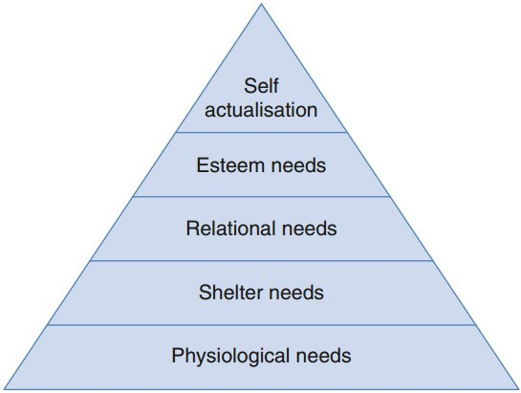
Figure 1. Maslow's Pyramid of Needs (Maslow, 1943).
References;
1. References should be listed alphabetically.
2. In-text APA 7 style should be used for in-text references and bibliography and should be added to the end of the paper. Examples of references are given below.
Examples of APA Citation style;

In-text notation:

Single-authored publications | (Surname, 2018)
Publications with two authors | (Surname and Surname, 2018)
Publications with three or more authors | (Surname et al., 2018)

End-of-text:

Book with one author | Surname, A. (Year), Title of Book (Italic), City: Publisher
Book with multiple authors | Book with multiple authors Surname, A., Surname, A., Surname, A. (Year), Title of Book (Italic), City: Publisher.
Book chapter: | Surname, A. (Year), Title of Chapter, Editor's A. Surname, Title of Book (Italic) in (p. page range) City: Publisher.
Article | Surname A. (Year), Title of the Article, Name of the Journal (Italic), Volume (Issue), page range.

